**LEARNING JOURNAL**

*Daily Report of Activities*

Name of Intern: ____________________________________________________

Department/Office: _________________________________________________

Supervisor: ________________________________________________________

|  |  |  |
| --- | --- | --- |
| **DATE** | **ACTIVITIES** | **LEARNINGS** |
| February 8, 2024 | Setting up the tables and chairs in the cafeteria was one of my first on-the-job training task at the IGP Office. Ma'am Reynalyn, the Head of IGP, had instructed us to do this daily, at 10 a.m. and 3 p.m. in the canteen. | After using something, you’ll have to maintain it. |
| February 12, 2024 | My second day of OJT involved folding paper to create a booklet, which the students then utilized for quizzes, exams, and other assignments that the instructors provided. | I learned how to fold and make a booklet. |
| February 13, 2024 | We continued making booklets. | Less mistakes making booklet |
| February 14, 2024 | Still making booklet. | Not giving up until I finished it all |
| February 15, 2024 | Ma’am Reynalyn asked us to go to the canteen to arrange again the chairs and tables. | Rearrange the tables and chairs after using it. |
| February 16. 2024 | 6th day of my OJT, still making more booklets. | I learned to stay focused when |
| February 19, 2024 | Making more booklets again since it isn’t finished. | I learned working isn’t easy as it sounds. |
| February 20, 2024 | Ma’am Reynalyn asked us to print her modules. | I learned other functions of print. |
| February 21, 2024 | Making green booklets is still being done, as advised by the IGP Head. | I learned that folding booklets is enjoyable |
| February 22, 2024 | Making yellow booklets is still being done, as advised by the IGP Head. | I learned that booklets have different colors. |
| February 23, 2024 | On my eleventh day of OJT, we have spent the entire day folding a booklet. | I learned an easy way of folding booklets |
| February 26, 2024 | Even on my twelfth day of OJT, we still spent the entire day creating a booklet. | I learned how to mastered folding booklets. |
| February 27, 2024 | Operational cleaning with my co-OJT and staff of IGP. | Helping one another is much bettter. |
| February 28, 2024 | We cleaned Ma’am Reynalyn’s computer setup. | Slowly but surely. |
| February 29, 2024 | Ma’am Reynalyn asked again to print her module exam for her students. | I learned that instructions must be followed. |
| March 1, 2024 | I count the booklets by ten. | Know the process of how the staff of IGP count the booklets. |
| March 4, 2024 | We put the booklets in order. | I acquired knowledge of good arrangement. |
| March 5, 2024 | Ma’am Reyna assigned me to enhanced and print a document. | To explore more knowledge. |
| March 6, 2024 | We, again prepare a booklet upon ma’am Reynalyn’s request. | I realized that I created more booklets in a short period of time, because I’m used to it . |
| March 7, 2024 | Still spent the entire day creating booklet. | I became a fast learner in terms of creating a booklet. |
| March 8, 2024 | Again, still creating a booklet. | To be patient all the time. |
| March 11, 2024 | Since there are a lot of booklets being created, my fellow OJT and I continue to create all day. | Knows the process and arranging it properly. |
| March 12, 2024 | Still creating booklets until it is done. | It is satisfying when the assigned task is finished. |
| March 13, 2024 | Again, ma’am Reynalyn asked to arrange tables and chairs in the canteen. | To always follow the task assigned. |
| March 14, 2024 | Being tasked to assist the IGP staff. | Everything that is made repeatedly can make you a fast worker. |
| March 15, 2024 | Counting and arranging booklet into 10. | To always be patient and humble whenever people asked you to do such task. |
| March 18, 2024 | Printed some module exams and reviewers. | Being an educator is not easy. |
| March 19, 2024 | Made booklets again. | Be patient enough. |
| March 20, 2024 | Made booklets again. | Be patient enough. |
| March 21, 2024 | Ma’am Reynalyn asked for some errands to do in the canteen. | It was very enjoyable to satisfy people about what they wanted. |
| March 22, 2024 | Printed Ma’am Reynalyn’s personal data. | Being an educator is not easy. |
| March 25, 2024 | I am asked to go to the campus director to sign some documents. | Be good at what they ask. |
| March 26, 2024 | I helped assess the staff to sell the booklets. | Everything that is made repeatedly can make you a fast worker. |
| March 27, 2024 | I helped at the IGP counter for there were many students asking and buying other staffs in there. | Helping others is free. |
| April 1, 2024 | I was assigned at the IGP counter. | Knowing each other makes having good buddies. |
| April 2, 2024 | Printed different documents. | Learning is to make you better. |
| April 3, 2024 | Cleaned the IGP counter with my co-OJT buddies. | Helping one another. |
| April 4, 2024 | Arranged booklets. | Stay positive always. |
| April 5, 2024 | Counted the yellow booklets. | Be humble and be patient. |
| April 8, 2024 | I am asked to go to the campus director to give the dormitory papers. | Be good at what they ask. |
| April 11, 2024 | I was assigned at the IGP counter. | Communicating with others is the best way. |
| April 12, 2024 | I was asked to print important documents to give to the research office. | Be patient enough. |
| April 15, 2024 | I was assigned at the IGP counter. | Communicating with others is the best way. |
| April 16, 2024 | Assisted in selling booklets. |  |
| April 17, 2024 | Do some errands. |  |
| April 18, 2024 | Ma’am Reynalyn asked me to print some documents. |  |
| April 19, 2024 | Ma’am Reynalyn asked me to print test papers. |  |
| April 22, 2024 | Assisted in selling booklets. |  |
| April 23, 2024 | Assisted in selling books and booklets. |  |
| April 24, 2024 | I was assigned at the IGP counter. |  |
| April 25, 2024 | Ma’am Reynalyn asked to print the booklet cover. |  |
| April 26, 2024 | Ma’am Reynalyn asked to get documents from the campus director. |  |
| April 29, 2024 | Assisted in selling booklets with my co-OJT. |  |
| April 30, 2024 | I and my co-OJT were assigned to the IGP counter. |  |
| May 2, 2024 | Assigned at the IGP counter and assisted in selling booklets. |  |
| May 3, 2024 | Ma’am Reynalyn asked to go to the BEM Department to get the documents. |  |
| May 6, 2024 | Assisted the staff in selling books for the education students. |  |
| May 7, 2024 | Assisted by co-OJT to count the booklets. |  |
| May 8, 2024 | I and my co-OJT were assigned to the IGP counter. |  |
| May 9, 2024 | Ma’am Reynalyn asked to get the papers from the BEM department. |  |
| May 10, 2024 | Assisted in printing the student's documents. |  |

**DOCUMENTATION**

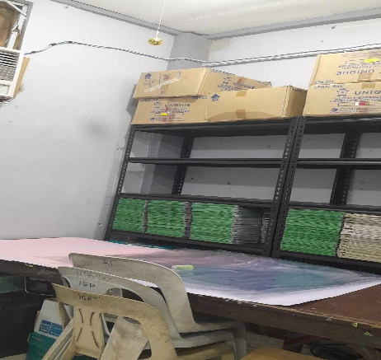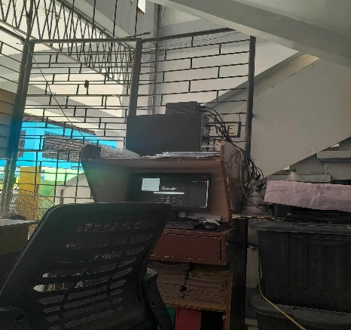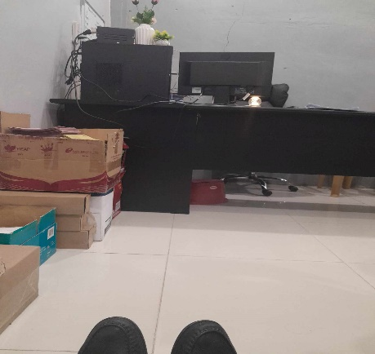

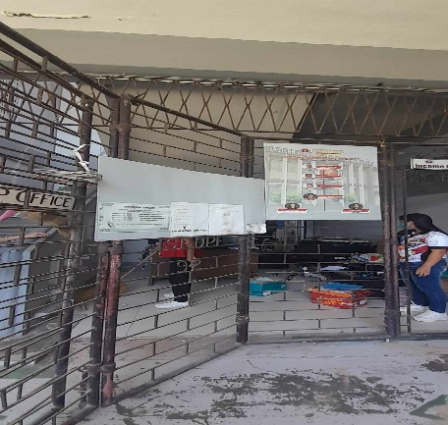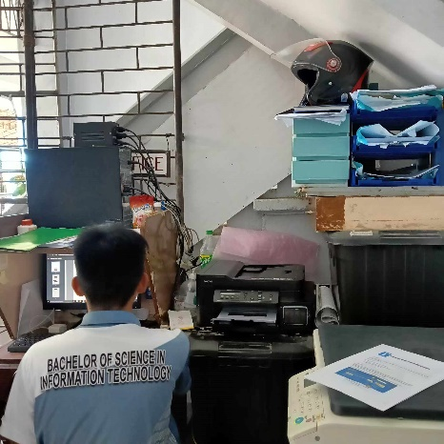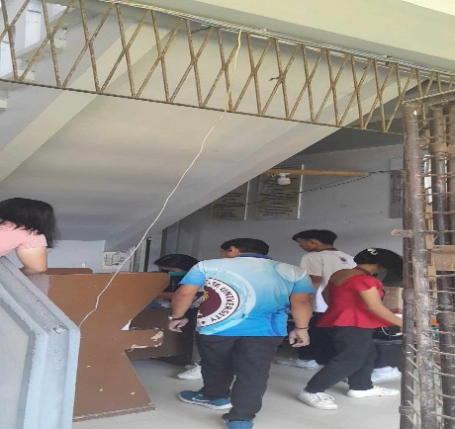

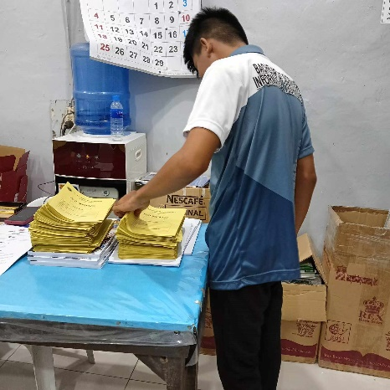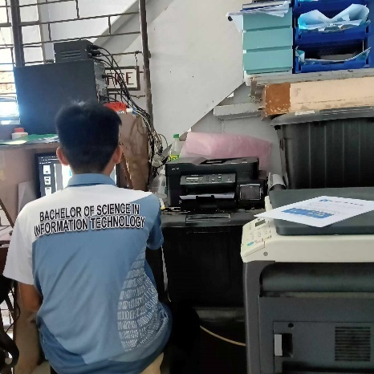

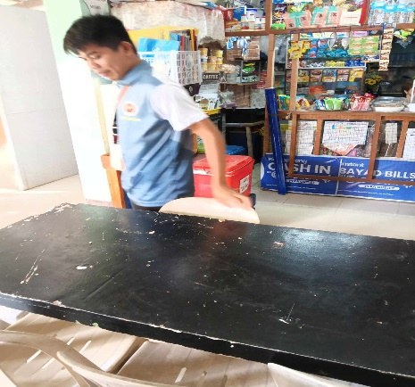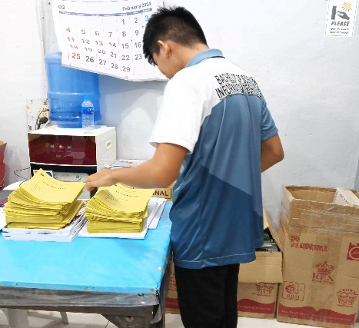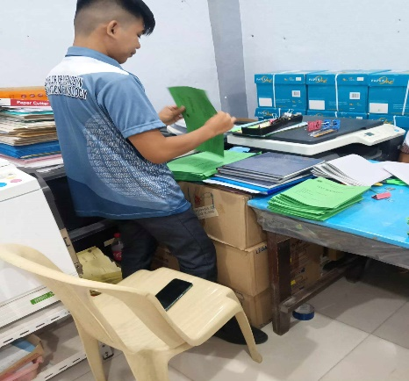

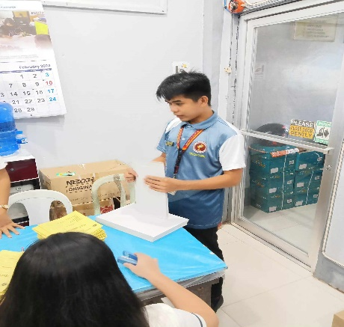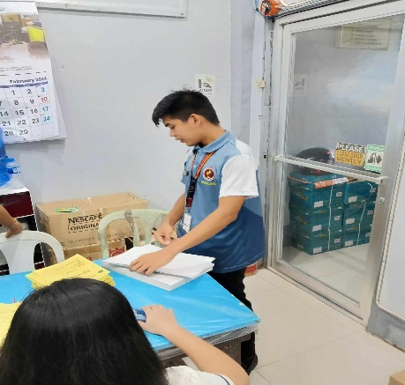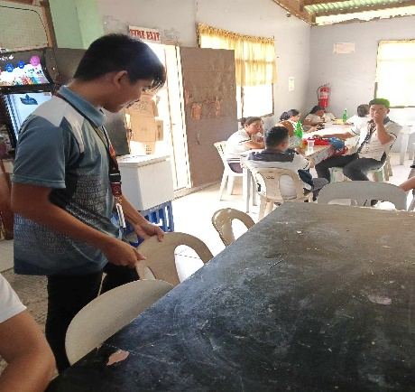

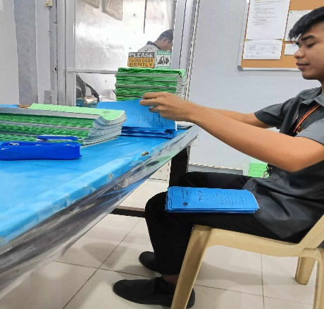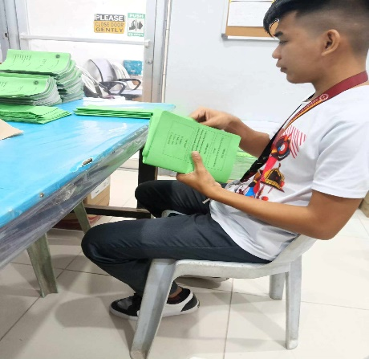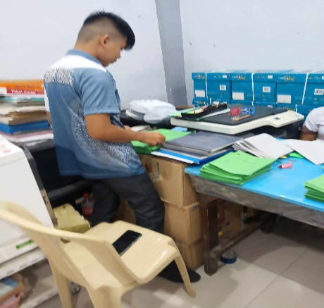

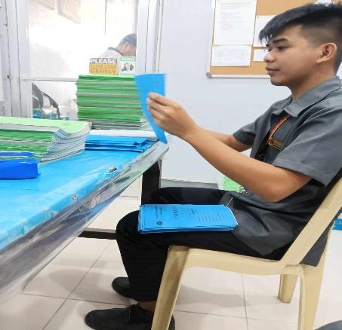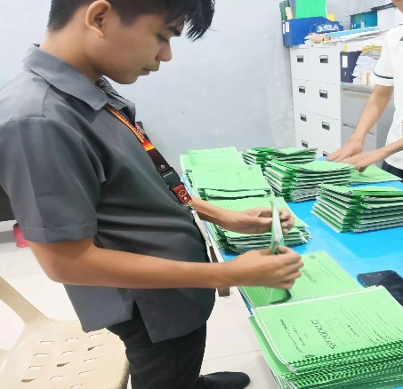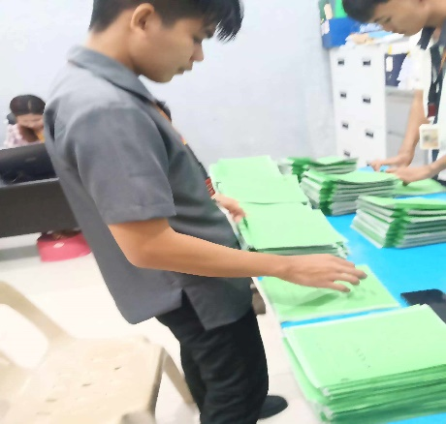

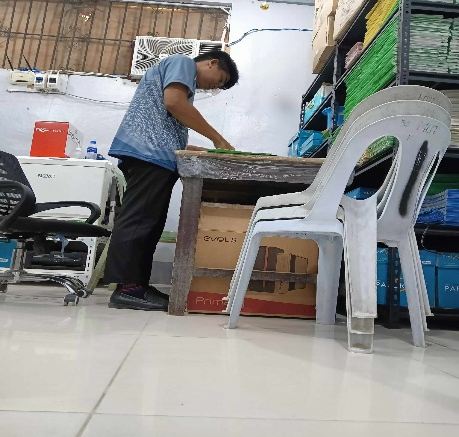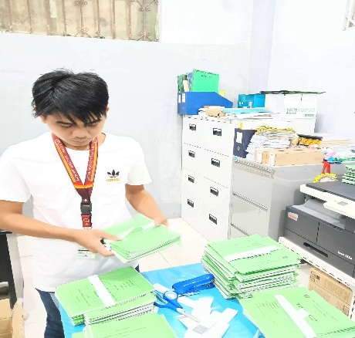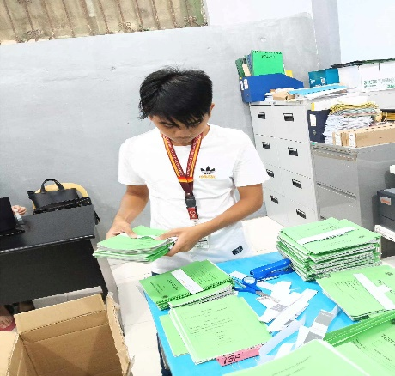

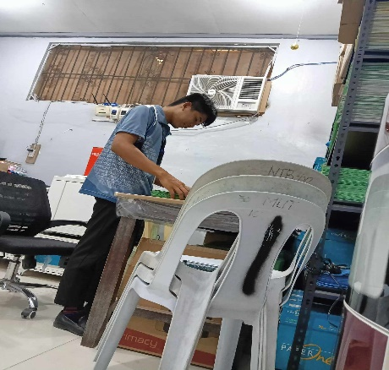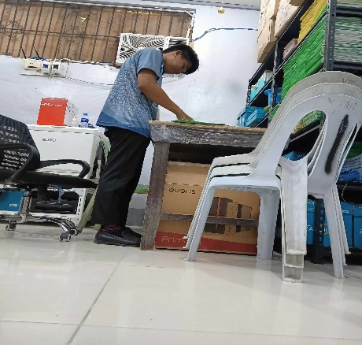

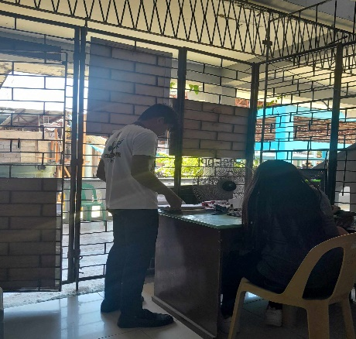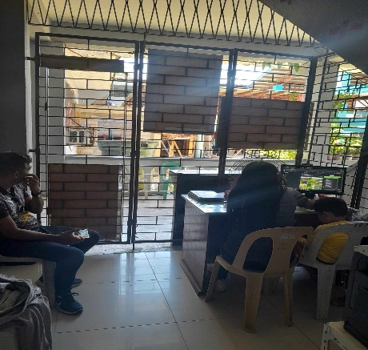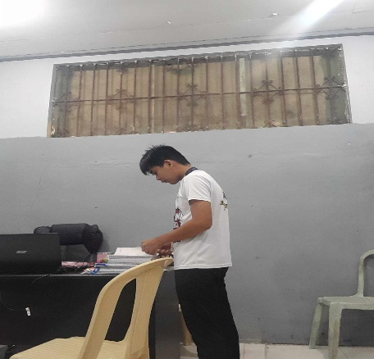

Prepared By: Reviewed By:

**EFREN JR. D. OLENDAN** **MICHAEL B. BATAN, MSIT**

Name of Intern BSIT OJT, Coordinator

Noted:

**VICENTE D. CARILLO JR. PhD**

Head, Engineering Department